No 1, 2003

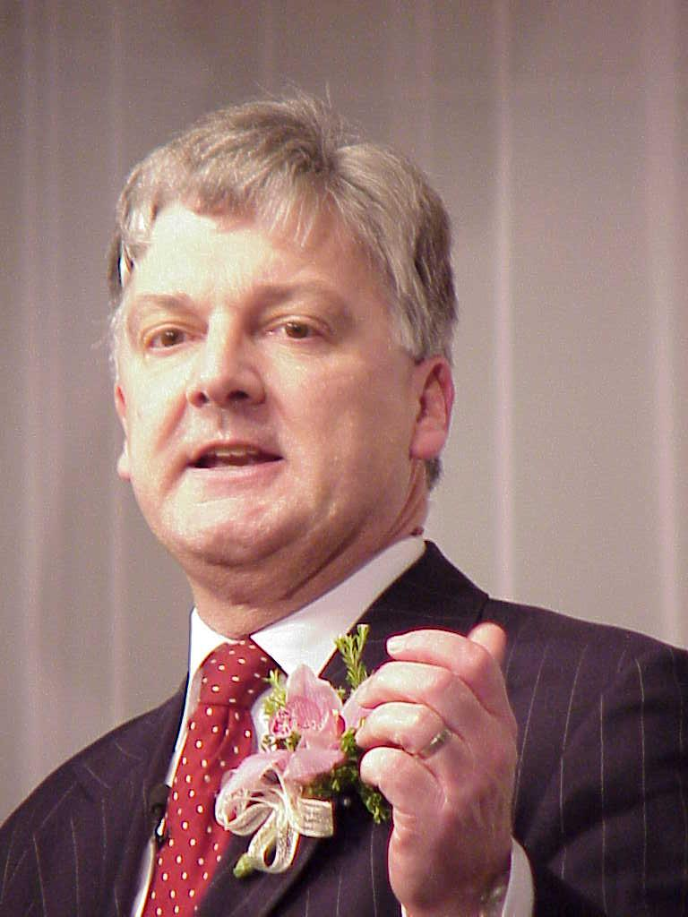
“United Future is making the big difference. We are making MMP work. The government is stable and able to implement its legislative programme. In most cases, this is because it gets support from United Future for what it wants to do. And in return, some of United Future’s own policies are being implemented. But there are also times when we oppose the government, which means they have to look to other parties for support. We are keeping them honest, but we are not throwing our toys out of the cot if we do not get our own way. We are being the sensible moderators we said we would be. Our aim is to become the party of influence in all future governments.”

As leader of United Future, Peter Dunne is in frequent demand around the country as a speaker. Here he sets out United Future’s vision for New Zealand.

IN AND AROUND OHARIU BELMONT

Peter Dunne officially opened the new community hall at Cashmere Avenue School on 1 May. He praised the development and said it will fill a great gap in the local community following the demolition of the previous historic community hall a little while ago.

The quality of local workmanship was celebrated once more at this year’s Pride of Workmanship Awards sponsored by the Johnsonville Rotary Club. Peter Dunne congratulated the award winners and urged them to be proud of their achievements “because they deserved to be.”

Nominations for this year’s Northern Wellington Voluntary Service Awards are now open. As Awards Committee chair Peter Dunne says the awards are there to recognise the achievements of community volunteers in the northern suburbs. People wishing to make nominations should contact his Johnsonville office. The awards will be announced at a special ceremony in July.

Peter Dunne took part in a special meeting of Western Hills residents recently to discuss the possibility of the STV voting system being adopted for future Hutt City elections. A strong STV supporter, he stressed that the decision was ultimately one for all Hutt City voters to make.

Regional transport issues are dominating meetings between Wellington MPs, regional Mayors and the Regional Council. All are extremely concerned about the future of urban rail services, especially on the Johnsonville and Melling lines where the old units have almost had their day. The group also wants Transit New Zealand to adopt the region’s road transport priorities, including a high priority for the development of Transmission Gully.

Peter Dunne now has a double. A new near life size puppet of the United Future leader has been unveiled at Wellington’s famous Backbencher pub and now sits alongside those of other well-known politicians.

PETER DUNNE SPEAKS OUT ON CURRENT ISSUES

United Nations Reform
“The United Nations failed to resolve the Iraq crisis not because the concept of the nations of the world acting in concert to prevent war is an outdated or unrealistic one, but because a long-feared flaw in the United Nations’ process stalled any chance of the Security Council agreeing a course of action. The existence of the great powers’ right to veto Security Council resolutions reduced the United Nations to impotence and left its efforts both to prevent war and bring an errant Iraq to heel looking somewhat pathetic. In the wake of the Iraq crisis the case for reform of the United Nations, including the removal of the veto, is compelling.”

Air New Zealand
“It’s time for Air New Zealand to stop wasting taxpayers’ money in its continued pursuit of an anti-competitive merger with Qantas. It’s time for Air New Zealand to get back to its primary job of running a quality airline for New Zealanders.”

Cold Winters Ahead?
“This year’s projected winter power shortage might be the first of many. There is far more to the looming crisis than a dry summer followed by a dry winter. This issue is really about our electricity generating capacity and how we ensure we can meet our future needs. Forthcoming changes to the Resource Management Act will go some of the way towards resolving the problem, but we still have to face up to the competing demands of our energy needs and our desire to preserve the conservation estate. Until we do so, and get the balance right, we can look forward to cold winters and more power shortages ahead. In the meantime, the government needs to be far more active in promoting energy conservation policies to make sure we can all make the savings needed to get us through this winter without the lights being turned off.”

UNITED FUTURE GETS RESULTS

United Future has successfully pushed for and already achieved a number of important policy milestones.

Resource Management Act to be Changed
The government has recently agreed to United Future’s proposals to make the controversial Resource Management Act more business-friendly. Work is presently underway preparing legislation on the changes United Future is recommending, for introduction to Parliament by the end of the year.

Families Commission
Bill Before Parliament
Legislation has been introduced to Parliament to set up the Families Commission promised by United Future at last year’s election. The Commission, which will ensure family concerns are at the heart of government policies will be in place by the middle of 2004. The government and United Future have also announced that a budget of $27 million has been set aside for the Commission over the next four years.

Gender Neutral Sex Laws On the Way
Following publicity by Peter Dunne of a case in the Ohariu Belmont electorate of a 13 year old boy having a sexual relationship with a 21 year old woman that was not against the law, the government announced plans to bring in new legislation to close this anomaly and make all laws regarding sexual abuse and assault gender-neutral so that they apply equally to males and females. The law is expected to be changed by the end of the year.
UNITED FUTURE UPDATE

Former Wellington Mayor Mark Blumsky and ex Miramar MP Graeme Reeves joined the board of United Future at the start of the year.

In other moves, Rob Eaddy has become the new chief of staff in Peter Dunne’s Parliamentary office, and Mark Stewart has joined the United Future team as a press secretary. Mr Eaddy was previously chief of staff to Jim Bolger when he was Prime Minister, while Mr Stewart was deputy editor of the Manawatu Evening Standard.

In recent months, United Future MPs have set up electorate offices in Albany, Auckland, Tauranga, Whakatane and Christchurch. Offices will shortly be opened in Hamilton and Dunedin.

In Ohariu Belmont, an active local team is working to promote the United Future message and promote the party.

More details about how you can become involved, or obtain more information about United Future policies and activities, or contact our MPs, are on our website:

www.unitedfuture.org.nz

